**Comparison between File System and DBMS**

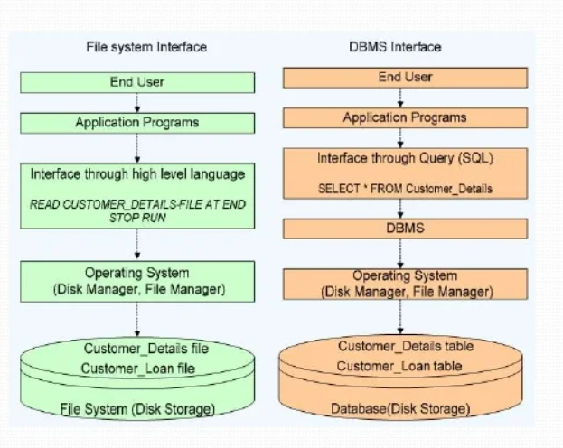

|  |  |
| --- | --- |
| **File System  e.g C++ or COBOL program** | **Database Management System e.g Mysql,Oracle** |
| Small System | Large System |
| Relatively cheap | Relatively expensive |
| Few Files | Many Files |
| File are files | Files are tables |
| Simple structure | Complex structure |
| Redundant data (duplicate data) | Reduced redundancy (Less duplication) |
| Chances of inconsistency (async/irregular) | Consistent(sync/regular) |
| Isolated data(independent) | Data can be shared(dependent) |
| Less Integrity | More Integrity |
| No security | More security |
| No backup and recovery | Having backup and recovery |
| Single user | Multiple users |